Course Enrollment Database
The Course Enrollment Database keeps student information, course details, and enrollment records organized in one place. It helps staff track who is taking each course, record grades, and view students’ course histories.
• Keeps student details, course information, and enrollment records in one place.
• Stores students’ names, email addresses, phone numbers, and class levels.
• Lists course titles, descriptions, credit hours, and departments.
• Tracks which students are taking which courses each semester.
• Records when students enroll and the grades they earn.
• Allows students to take multiple courses and each course to have multiple students.
• Makes it easy to look up class lists and a student’s course history.
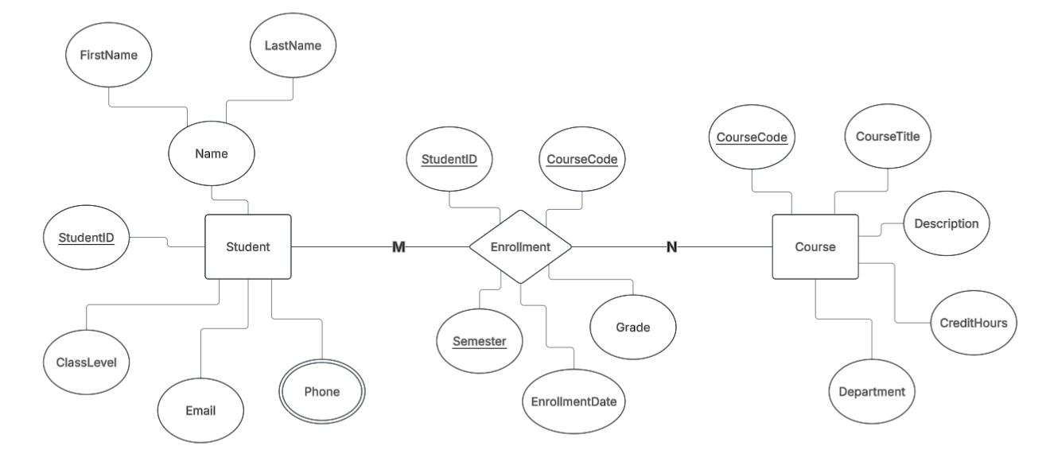

This script creates a fresh database to organize student and course information. It sets up four sections for student details, phone numbers, courses, and enrollments.
These sections work together to track who is taking each course, when they enrolled, and the grades they earn. The setup also helps prevent duplicate records and keeps enrollment information connected to the correct students and courses.
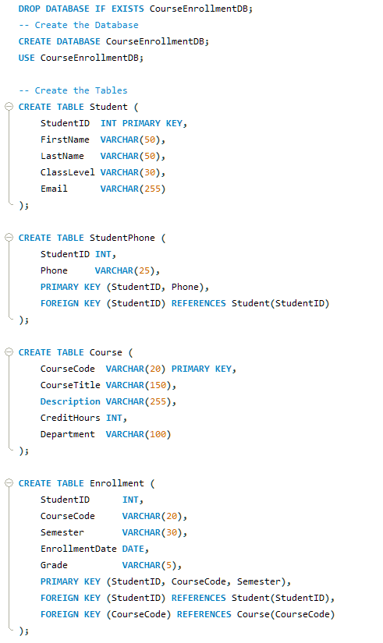

This CSV file lets us add several students to the database at once instead of entering their information individually. Each row represents one student and includes their student ID, first name, last name, class level, and email address.
During the import, these values are matched to the corresponding fields in the Student table. Before importing, we check that the information is complete, the student IDs are unique, and the columns match the expected format.
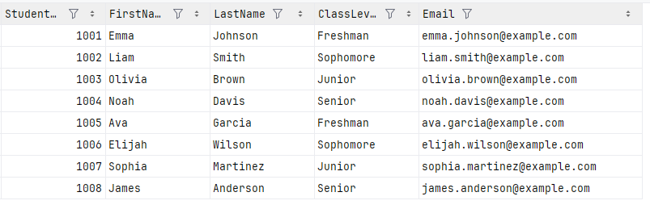
This is the main menu of our Course Enrollment application. It provides simple options for adding students, phone numbers, courses, and enrollment details.
We can also view a list of all students, look up their phone numbers, or find the courses a student is taking using their student ID.
Each button opens a specific task, making it easy to manage and find information without working directly with the database.
